Model Findings Report: Online Shopper Purchasing Prediction
Project Title: Predicting Online Shopper Purchasing Intentions
Course: MSBA 8490 – Data Analysis
Student: Shraddha Manandhar
Date: November 2025

Table of Contents
Model Findings Report: Online Shopper Purchasing Prediction 1
1. Introduction 4
2. Data Overview 4
3. Methods 4
3.1 Logistic Regression 4
3.2 Random Forest 5
4. Analysis 5
4.1 Logistic Regression Model Performance (Test Set) 5
4.2 Random Forest Model Performance (Test Set) 5
4.3 Side-by-Side Comparison 6
5. Results and Insights 6
6. Business Implications 7
6.1 Marketing 7
6.2 Customer Experience 7
6.3 Operations & Inventory 7
6.4 Leadership Decision Support 7
7. Recommendations 7
Short-Term 7
Medium-Term 8
Long-Term 8
8. Conclusion 8
9. Appendix 9
Appendix A. Modeling Code 9
A1. Data Preparation and Transformations 9
A2. Train/Test Split 10
A3. Training Control Setup 10
A4. Logistic Regression Model 11
A5. Random Forest Model 11
A6. Predictions and Evaluation Metrics 11
Appendix B. Full Model Outputs 13
B1. Logistic Regression Confusion Matrix 13
B2. Logistic Regression Performance Metrics 13
B3. Random Forest Confusion Matrix 13
B4. Random Forest Performance Metrics 13
B5. Side-by-Side Comparison of Models 14
Appendix C. Diagnostic Plot 14
C1. Random Forest Tuning Plot (ROC vs. mtry) 14

1. Introduction
The purpose of this analysis was to determine whether customer session behavior on an e-commerce website can be used to accurately predict the likelihood of purchase. As part of the broader business objective of improving marketing efficiency, optimizing the customer journey, and supporting data-driven decisions, this Modeling Findings Report provides a performance comparison of two predictive models:
- Logistic Regression
- Random Forest
These models were selected based on their interpretability, predictive power, and suitability for classification problems with imbalanced outcomes (only 15.5% of sessions resulted in a purchase).
This report summarizes the modeling approach, key performance metrics, and business implications of the findings, and recommends next steps to maximize the value of predictive analytics for the organization.

2. Data Overview
The modeling dataset consisted of 12,205 unique online shopping sessions, each recorded with user engagement metrics (e.g., number of pages viewed, time on site), behavioral indicators (e.g., bounce and exit rates), and contextual factors (e.g., month, visitor type, traffic source). The target variable, Revenue, indicates whether the session resulted in a purchase.
Because the data was highly skewed (e.g., duration variables had extremely long right-tails), log transformations were applied to better stabilize variance and improve predictive performance. The target variable was recoded from "TRUE/FALSE" to "yes/no" to allow proper probability estimation within the caret framework.
A stratified train-test split ensured that the purchase rate remained consistent (~15.5%) across both sets.

3. Methods
Two supervised machine learning models were developed:

3.1 Logistic Regression
Chosen for interpretability.
Preprocessing steps included:
- Centering and scaling of numeric features
- Use of log-transformed duration variables
- 5-fold cross-validation repeated 3 times
- ROC as the optimization metric
This model provides insight into how specific behavioral variables influence the likelihood of purchase.

3.2 Random Forest
Selected for its ability to model complex, nonlinear relationships.
Settings included:
- 5-fold repeated cross-validation
- Tuning across multiple mtry values
- ROC-based selection of best model (optimal mtry = 8)
This model is less interpretable but often more accurate.

4. Analysis

4.1 Logistic Regression Model Performance (Test Set)
Accuracy: 0.898
Precision: 0.731
Recall: 0.540
F1 Score: 0.621
AUC: 0.912
Interpretation:
Logistic regression provides strong discriminatory power (AUC = 0.912), meaning it is effective at ranking high-intent shoppers above low-intent ones. However, recall is moderate (0.54), meaning the model misses nearly half of true purchasers. This is expected given class imbalance and the linear nature of the model.

4.2 Random Forest Model Performance (Test Set)
Accuracy: 0.905
Precision: 0.742
Recall: 0.587
F1 Score: 0.656
AUC: 0.927
Interpretation:
Random Forest delivered the strongest overall predictive performance, outperforming logistic regression on every metric:
- Higher accuracy
- Higher recall (captures more purchasers)
- Higher F1 score
- Highest AUC (0.927)
This model better captures nonlinear interactions between engagement indicators and purchase outcomes.
The Random Forest model outperformed Logistic Regression across all key metrics, including recall and AUC, indicating stronger predictive performance and better identification of high-intent users.

4.3 Side-by-Side Comparison
Metric | Logistic Regression | Random Forest | Winner
Accuracy | 0.898 | 0.905 | RF
Precision | 0.731 | 0.742 | RF
Recall | 0.540 | 0.587 | RF
F1 Score | 0.621 | 0.656 | RF
AUC | 0.912 | 0.927 | RF
Result:
Random Forest is the best-performing model and should be recommended for operational use.

5. Results and Insights
Key Findings:
- Random Forest consistently outperforms Logistic Regression in identifying purchase-intent sessions.
- Both models demonstrate strong AUC scores, indicating that session behavior is predictive of purchasing likelihood.
- The strongest contributing factors (from EDA and model behavior) align with business intuition:
  - PageValues (proxy for high-value activities)
  - ProductRelated pages & duration
  - BounceRates & ExitRates
  - VisitorType (Returning Visitors convert more)
  - Month (seasonality: Aug–Nov strongest)
- The moderate recall values reflect the inherent business challenge: most visitors do not purchase, but the models still succeed in distinguishing high-intent sessions.

6. Business Implications

6.1 Marketing
- Use predictions to prioritize remarketing to sessions flagged as high-intent.
- Allocate higher ad budgets during months with naturally higher purchasing likelihood (Aug–Nov).

6.2 Customer Experience
- Reduce bounce behavior by optimizing landing pages and checkout flow.
- Encourage deeper product-related engagement (e.g., recommendations, similar items).

6.3 Operations & Inventory
- Forecast demand more accurately by combining model outputs with seasonal trends.
- Use predicted high-intent sessions for staffing, inventory, and fulfillment planning.

6.4 Leadership Decision Support
- Offers a data-backed foundation for decisions on UX redesign, marketing spend, and personalization strategy.

7. Recommendations

Short-Term
- Implement the Random Forest model for real-time purchase intent scoring.
- Focus on reducing bounce rates and increasing product engagement to lift conversion.
- Use high-intent predictions to drive targeted email and remarketing campaigns.

Medium-Term
- Collect additional features such as session device type, cart abandonment details, and time-of-day.
- Explore additional models (Gradient Boosting, XGBoost) to further improve recall.

Long-Term
- Build a full Marketing Personalization Engine using these model outputs.
- Integrate predictions with CRM tools for customer lifecycle management.

8. Conclusion
This analysis confirms that session-level behavior is a strong predictor of online purchasing intent. Both models performed well, but Random Forest is superior across all key metrics and is the recommended model for operational decision-making.
By leveraging predictive modeling, the organization can significantly improve conversion strategies, optimize marketing spend, and proactively support customer needs, ultimately increasing revenue and customer satisfaction.

9. Appendix

Appendix A. Modeling Code
This appendix provides the complete R code used for data preparation, model development, and model evaluation. Code is presented to ensure reproducibility and to provide full transparency into the modeling workflow.

A1. Data Preparation and Transformations
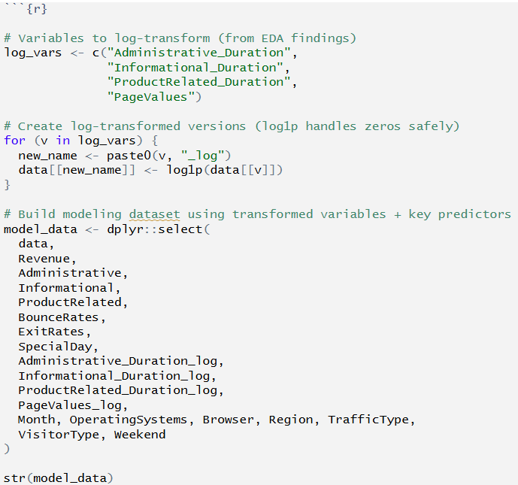

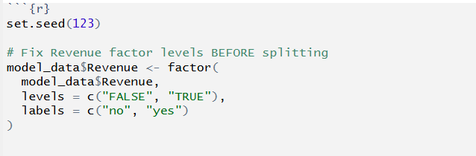
Figure A1. R code for data preparation and transformations

A2. Train/Test Split
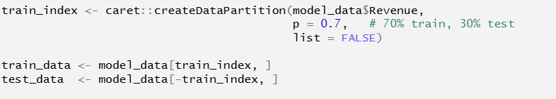
Figure A2. R code for Train/Test Split

A3. Training Control Setup
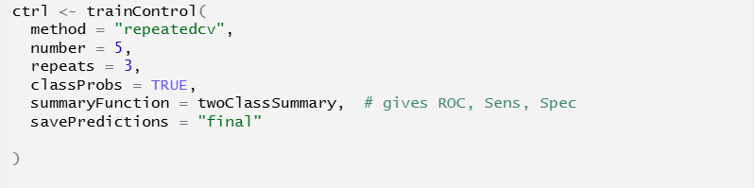
Figure A3. R code for Training Control Setup

A4. Logistic Regression Model
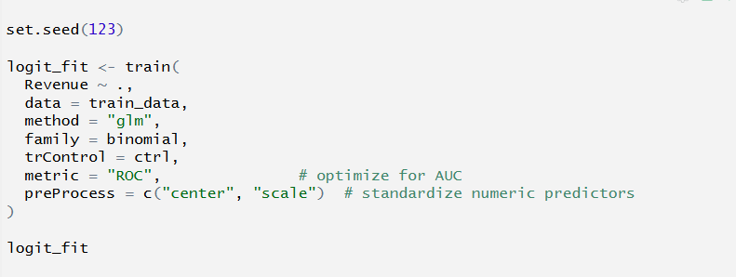
Figure A4. R code for Logistic Regression Model

A5. Random Forest Model
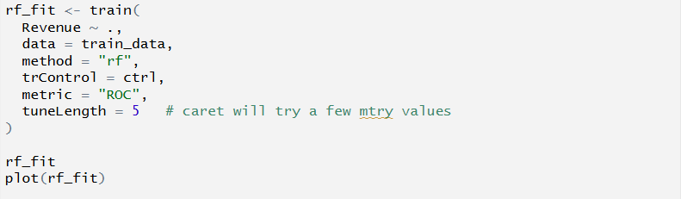
Figure A5. R code for Random Forest Model

A6. Predictions and Evaluation Metrics
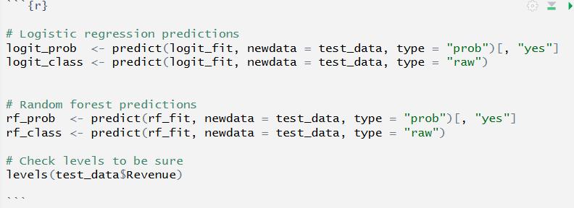

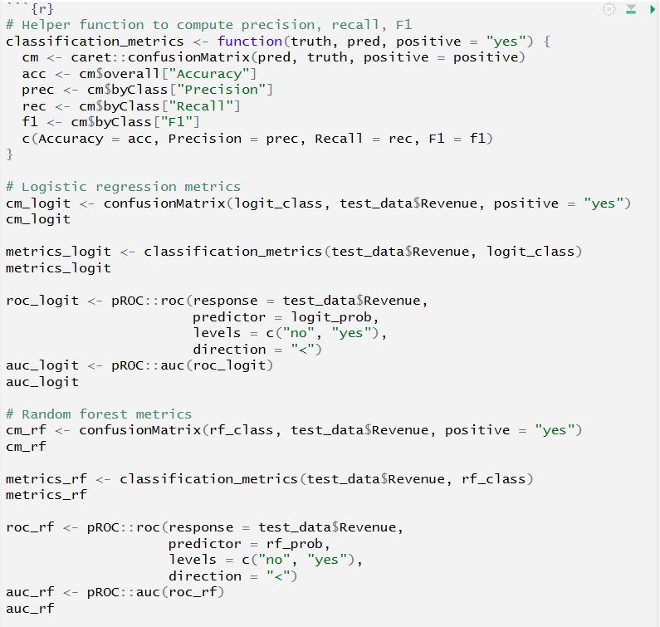
Figure A6. R code for Predictions and Evaluation Metrics

Appendix B. Full Model Outputs

B1. Logistic Regression Confusion Matrix
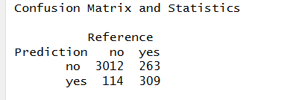
Figure B1. Confusion matrix for logistic regression model

B2. Logistic Regression Performance Metrics
Metric | Logistic Regression
Accuracy | 0.898
Precision | 0.731
Recall | 0.540
F1 Score | 0.621
AUC | 0.912
Figure B2. Logistic Regression Performance Metrics

B3. Random Forest Confusion Matrix
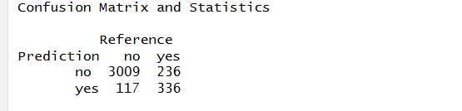
Figure B3. Random Forest Confusion Matrix

B4. Random Forest Performance Metrics
Metric | Random Forest
Accuracy | 0.905
Precision | 0.742
Recall | 0.587
F1 Score | 0.656
AUC | 0.927
Figure B4. Random Forest Performance Metrics

B5. Side-by-Side Comparison of Models
Metric | Logistic Regression | Random Forest
Accuracy | 0.898 | 0.905
Precision | 0.731 | 0.742
Recall | 0.540 | 0.587
F1 Score | 0.621 | 0.656
AUC | 0.912 | 0.927
Figure B5. Side-by-Side Comparison of Models

Appendix C. Diagnostic Plot

C1. Random Forest Tuning Plot (ROC vs. mtry)
Description:
This plot shows the ROC (Repeated Cross-Validation) score across different values of mtry, representing the number of randomly selected predictors considered at each split. The Random Forest achieved the highest ROC performance at mtry = 8, which is why the model selected this value automatically during tuning.
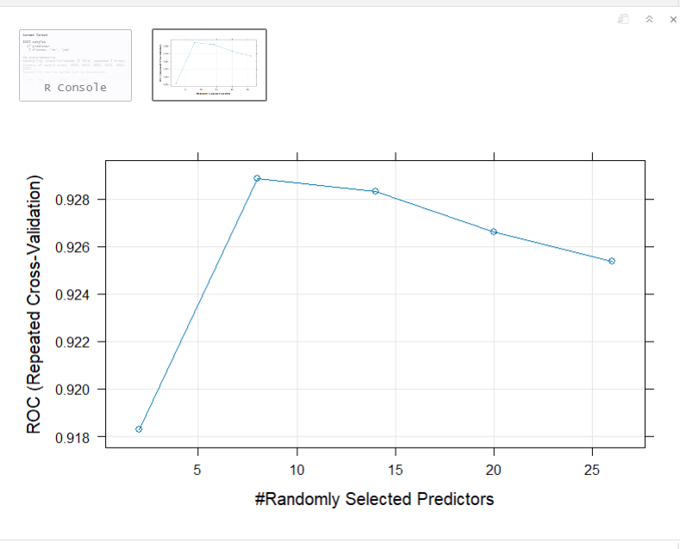
Figure C1. Random Forest ROC by mtry

Interpretation:
- ROC increased sharply between mtry = 2 and mtry = 8
- The peak occurs at mtry = 8, indicating best overall predictive performance
- Performance decreases at larger mtry values, confirming that including too many variables hurts generalization
- This supports the conclusion that the Random Forest model is appropriately tuned and stable

